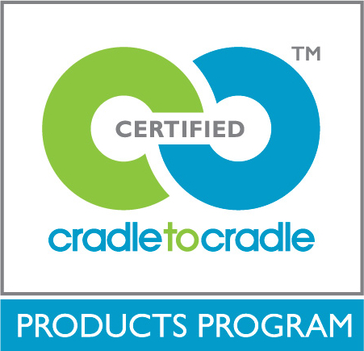
VOC Emissions Testing Form
Last Revision: April 2017
Cradle to Cradle Products Innovation Institute

Instructions
This form must be completed by assessors preparing Cradle to Cradle certification applications for products for which VOC emissions testing has been done. Check all boxes that apply and provide any additional required information based on the chosen answers. Additional instructions are provided in italics where needed.

Product Information
Provide the company name and product group name below.

Company: | [Company Name]
Product Group: | [Product Group Name]
Date Completed:

Test Methods
Instructions: Check one to indicate which of the following Standard-approved test methods has been used, and complete any text fields required based on the chosen answers.
ASTM D5116 for small chamber or equivalent
EU standard
ASTM D6670 for large chamber or equivalent EU standard
Name of equivalent EU standard, if applicable: [...]
ANSI/BIFMA M7.1 for office furniture or equivalent EU standard
Name of equivalent EU standard, if applicable: [...]
ISO 16000 series for VOCs

Loading Scenarios
Check one to indicate which of the following Standard-approved loading scenarios has been used.
ANSI/BIFMA M7.1 (for office furniture)
California Department of Health Services section 01350 (for all other products)

Thresholds
Check all that apply, and complete any text fields required based on the chosen answers.
Required. Individual VOCs, of which the TLV or MAK value is known, are <(0.01) x [the lower of the TLV or MAK value].
Required. VOCs that do not otherwise have a known TLV or MAK value that are considered known carcinogens, endocrine disruptors, mutagens, reproductive toxins, or teratogens are below detection limits. Detection limits are <9.0 μg/m³ for formaldehyde and <2µg/m³ for all other chemicals.
Description of detection limits: [...]
Required. Total VOC emissions are <0.5 mg/m³.

Target VOCs
Check all that apply.
Required. The VOCs with established Chronic Reference Exposure Levels (CRELs) listed in the California Department of Public Health's (CDPH) Standard Method v1.1-2010 were included in emissions testing.
The product is carpeting or other flooring. 4-Phenylcyclohexene has also been included in emissions testing.

Other
Check all that apply.
Required. The time point used was 7 days (measured or interpolated) for VOCs and IVOCs.
Required. The analytical laboratory used is ISO 17025 accredited.

