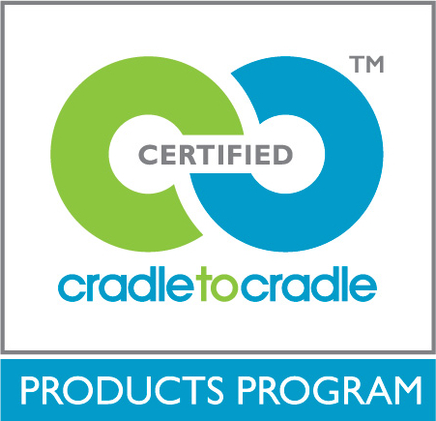

Externally Managed Component (EMC) Form
Last Revision: December 2015
Cradle to Cradle Products Innovation Institute

Instructions

This form must be completed by assessors preparing Cradle to Cradle certification applications for products that contain an Externally Managed Component (EMC). If a product contains more than one EMC, one form must be provided for each EMC. Check all boxes that apply and provide any additional required information based on the chosen answers. Additional instructions are provided in italics where needed.

Product Information
Provide the company name and product group name below.

Company: Company Name

Product Group: Product Group Name

EMC Eligibility
Required. The EMC is a sealed component that is manufactured in a way that prohibits the migration of chemicals and materials from the component. During the use of the product for which the EMC is a component, users are not exposed to any part or chemical within the component, and no part or chemical within the component is released to the environment.
Description of EMC and how it meets this requirement:

EMC Assessment: Material Reutilization
Required. The applicant or the EMC supplier has provided a guarantee for take back and appropriate nutrient management. A signed statement from the applicant or the EMC supplier is attached. It includes a full description of the take-back program and how the product or material will be returned.
Percentage of the EMC that is considered recyclable after take-back: %

Description of how this percentage was determined:

EMC Assessment: Material Health
Required. The EMC meets the banned list requirements.
Description of how banned list compliance was determined:

Required. The EMC supplier has signed a declaration that chemicals in the EMC will not negatively impact humans or the natural environment during the intended and unintended but highly likely use of the product for which the EMC is a component. This signed declaration is attached.
Description of the evidence used as the basis for this declaration (such a declaration may be provided if the EMC is Cradle to Cradle Certified™ (Gold level or higher), or other appropriate evidence):

Required. All possible pathways of migration of harmful substances in the EMC during the use of the product have been considered. Harmful substances are not being released from the EMC above the chemicals’ analytical detection limits.
Description of potential pathways of migration of harmful substances:

Description of how it was determined that harmful substances are not being released from the EMC above the chemicals’ analytical detection limits (testing, studies, formulation information, etc.):

The product containing the EMC is used outdoors only. VOC emissions testing is not required.

The product containing the EMC is not exclusively used outdoors. The product meets the Cradle to Cradle Certified VOC emission standards as specified in Section 3.9 of the standard and guidance. Test results have been evaluated and are attached.

Summarize the test results below by checking all that apply and completing any text fields required based on the chosen answers.

Test Methods
Check one to indicate which of the following Standard-approved test methods has been used, and complete any text fields required based on the chosen answers.

ASTM D5116 for small chamber or equivalent

EU standard

ASTM D6670 for large chamber or equivalent EU standard
Name of equivalent EU standard, if applicable:

ANSI/BIFMA M7.1 for office furniture or equivalent EU standard
Name of equivalent EU standard, if applicable:

ISO 16000 series for VOCs

Loading Scenarios
Check one to indicate which of the following Standard-approved loading scenarios has been used.

ANSI/BIFMA M7.1 (for office furniture)

California Department of Health Services section 01350 (for all other products)

Thresholds
Check all that apply, and complete any text fields required based on the chosen answers.

Required. VOCs that are considered known carcinogens, endocrine disruptors, mutagens, reproductive toxins, or teratogens are below detection limits. Detection limits are <9.0 μg/m³ for formaldehyde and <2µg/m³ for all other chemicals.
Description of detection limits:

Required. Total VOC emissions are <0.5 mg/m³.

Required. Individual VOCs are <(0.01) x [the lower of the TLV or MAK value].

Target VOCs
Required. The VOCs with established Chronic Reference Exposure Levels (CRELs) listed in the California Department of Public Health's (CDPH) Standard Method v1.1-2010 were included in emissions testing.

Other
Check all that apply.

Required. The time point used was 7 days for VOCs and IVOCs.

Required. The analytical laboratory used is ISO 17025 accredited.

